Appendix A:

# Summary of Data:

Training set – Target Variable Characteristics:

# 

The training set consists of 383 observations with an average SalePrice ~= 138k.

For the BrkSide neighborhood specifically:

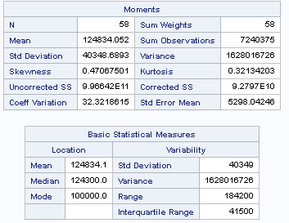

The training set consists of 58 observations with an average SalePrice ~= 125k.

For the Edwards neighborhood specifically:

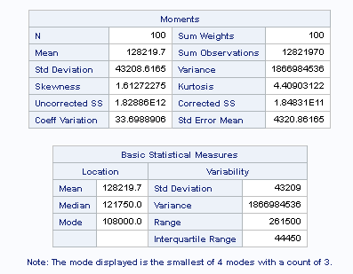

The training set consists of 100 observations with an average SalePrice ~= 128k.

For the Edwards neighborhood specifically:

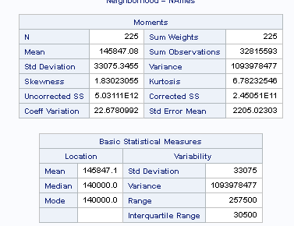

The training set consists of 225 observations with an average SalePrice ~= 145k.

# 